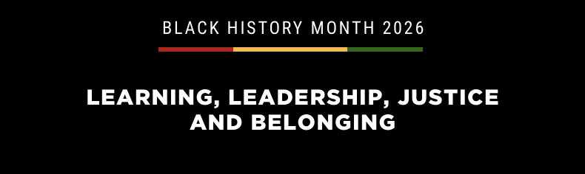
Takura Makoni

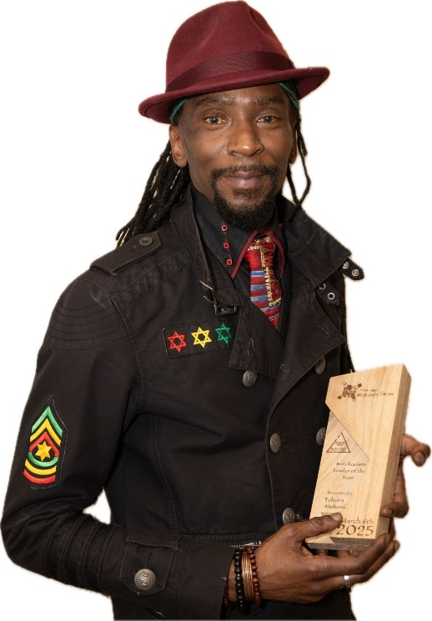

Born in Leeds to his Zimbabwean migrant student parents, Takura Donald Makoni had a travelled childhood.
Bouncing between the UK, Lesotho, Zimbabwe and Botswana and inspired by his father's activism and his mother's steadfast support and guidance, his life was enriched with a diverse palate shaping his curious mind.
Takura is currently employed by The African & Caribbean Support Organisation of Northern Ireland (ACSONI) as their Policy Officer. His tireless activism and campaigning on behalf of society’s most vulnerable were recognised by the Advancing Race Equality Awards judging panel in 2025 when they named him Anti-Racist Leader of the Year Award.
Over his 20+ years living in Northern Ireland, Takura Makoni has become a point of contact for multiple organisations, including Belfast City Council, Beyond Skin, Arts Ekta, Glen Bank Community Centre, Terra Nova Productions, National Museums Northern Ireland and the JoinHer Network.
It is these connections that cement the feeling of ‘home’ that inspired him to settle in Belfast to seek and secure a better life for his family than was available in his economically deteriorating ancestral home of Zimbabwe.

