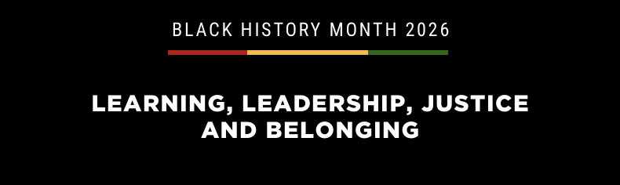
KEITH FRASER



Keith Fraser is a nationally respected thought leader in policing, youth justice and inclusive public leadership across England and Wales. As Chair of the Youth Justice Board, a member of the Criminal Justice Board and former UK Commissioner on Race and Ethnic Disparities, he has shaped national policy and governance while staying grounded in regional delivery through senior operational roles in West Midlands Police and the Metropolitan Police Service.
Keith champions balanced “hard and soft” approaches: Proportionate enforcement alongside inclusive leadership, cultural competence and trust building, demonstrating how fairness and legitimacy reduce violence and improve outcomes. At national level he convenes cross-government stakeholders to embed accountability and data driven decision-making. At regional level he translates strategy into practice through workforce development, blind recruitment and rigorous performance oversight.
A values-led collaborative leader, Keith brings plain English clarity, political acuity and operational credibility to the politics of justice. He aligns system reform with measurable impact using evidence to challenge disproportionality, strengthen prevention and improve youth custody pathways while ensuring people, dignity and opportunity remain central.
His portfolio spans chairing the Public Chairs’ Forum and Local Partnerships, advising ministers on youth justice and training senior police leaders, all focused on creating fair environments that lift trust and productivity. Keith’s approach marries governance discipline with lived experience insight.

